**Book My Show Web App**

**Description**

BookMyShow is an online ticketing platform that allows users to book movie tickets in India and admins can add movies.

**Key Features**

* Users can browse through various movies happening in their cities and book tickets for the same.
* The application is available in multiple languages, making it convenient for users to navigate and book tickets.
* Users can choose their preferred seats from the basic and premium seats book according to their prices.
* Users can watch trailers of movies and get information about the plot, cast, and crew of the movie.
* Users can view their past bookings and track their upcoming bookings from the application.

**Admin/User SignUp page:** To create an account in the webapp

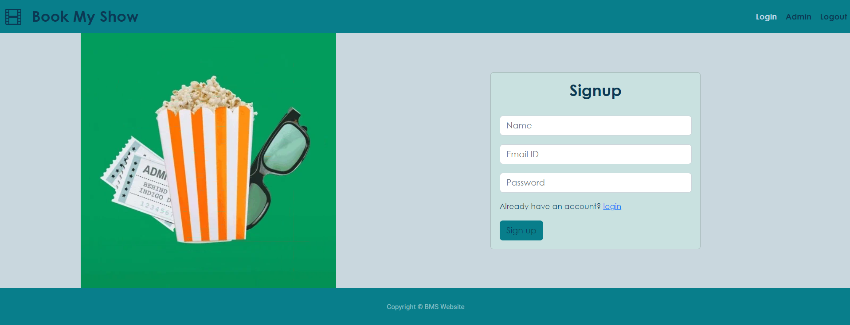

**Admin/User SignIn Page:** To provide access to webapp for existing users.

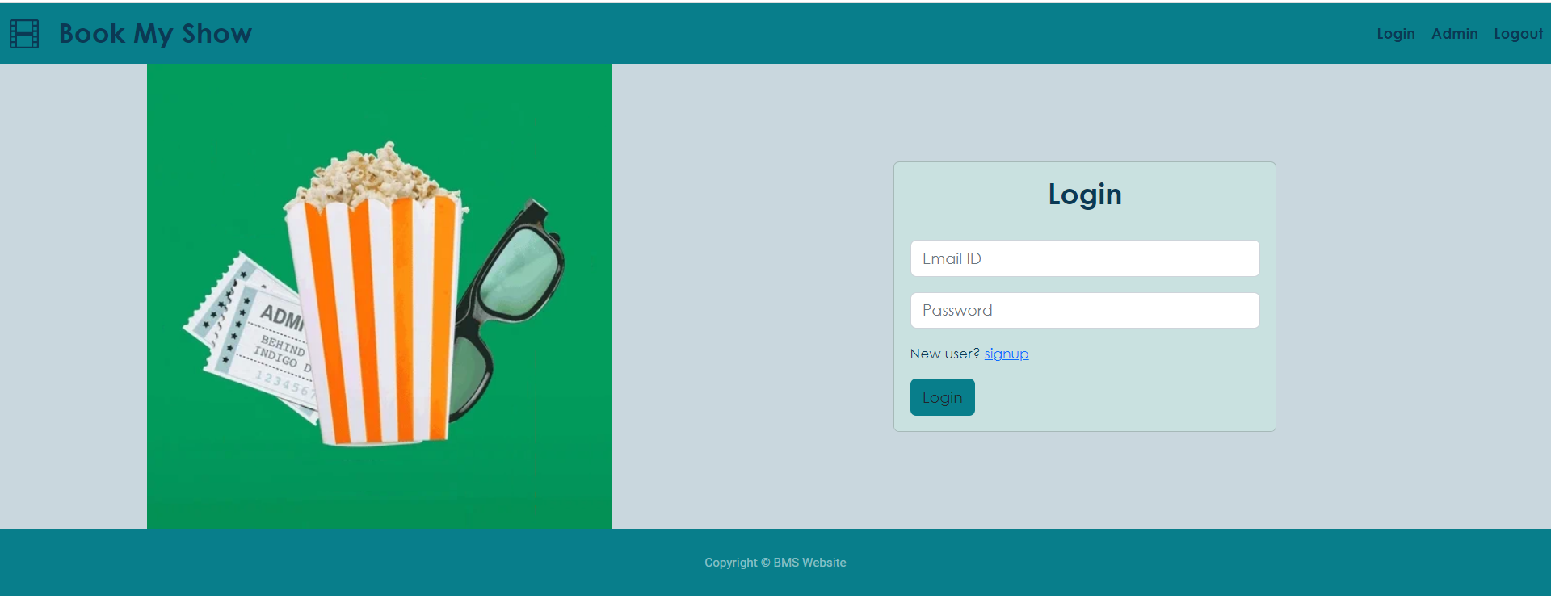

**Movie Filter/Movie list Page:** Able to view list of moveis and filter the movies from list.

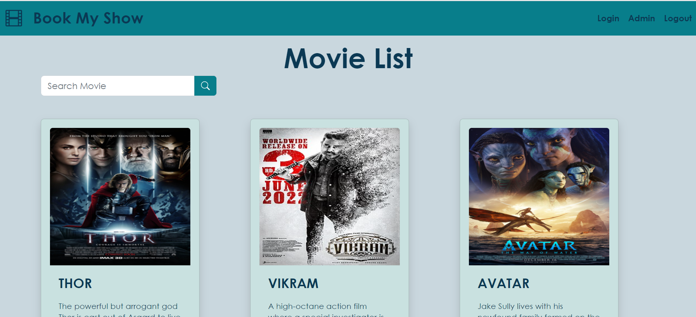

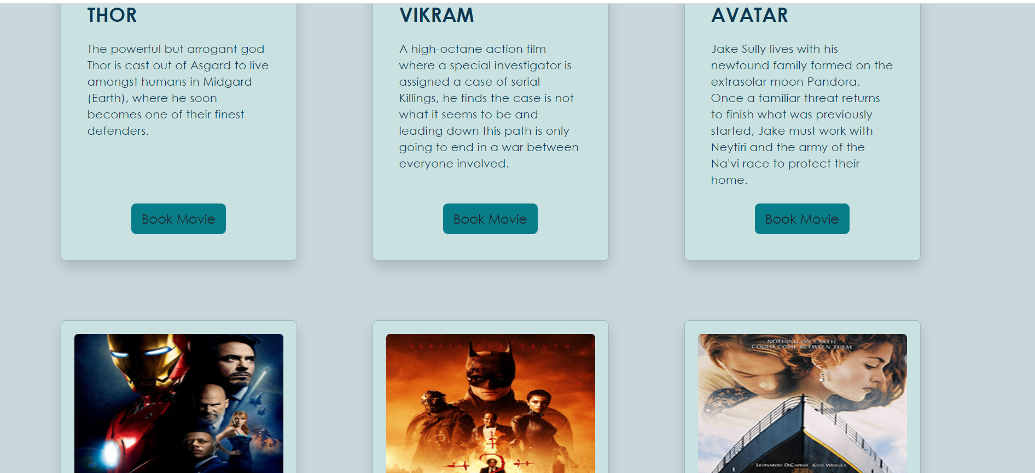

**Movie Detail Page/List of Cities and Theaters page:** able to watch movie trailer and find out the list of cities and theaters.

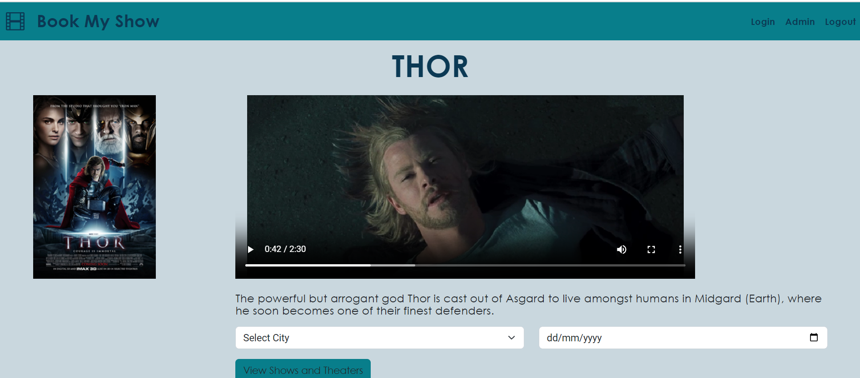

**Booking Page:** To book the Movie on post selection of city and date.

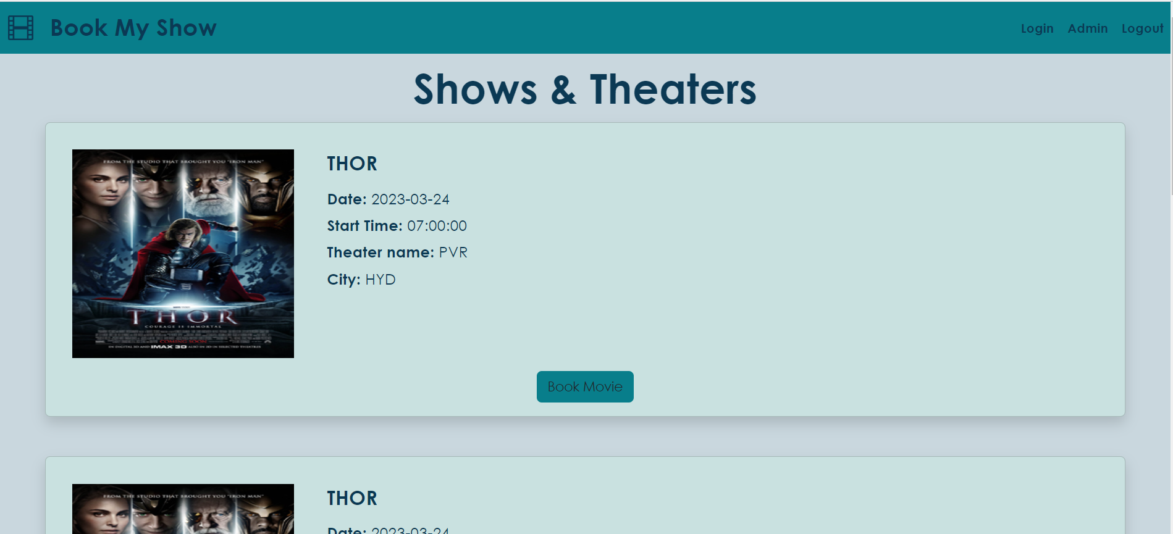

**Before booking of seats**: Entries of our DB

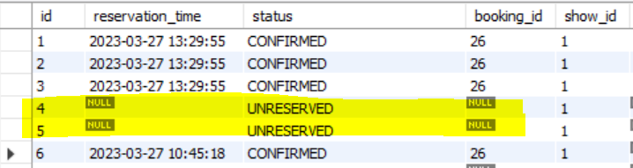

**Seat Selection:**

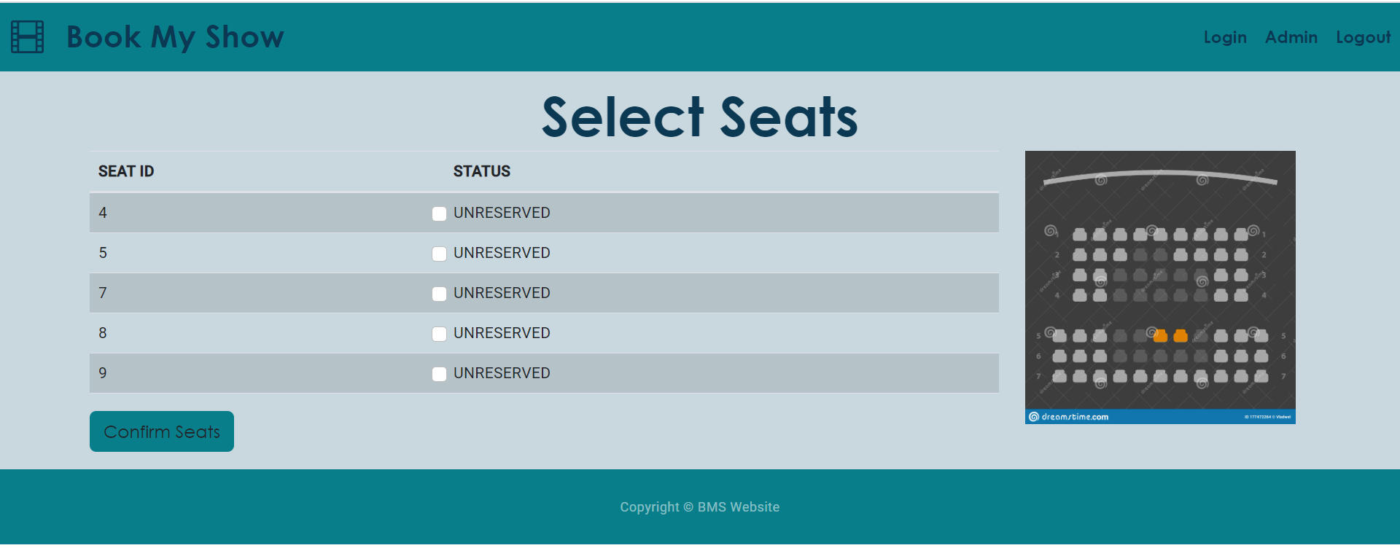

**After booking of seats:** Entries of our DB

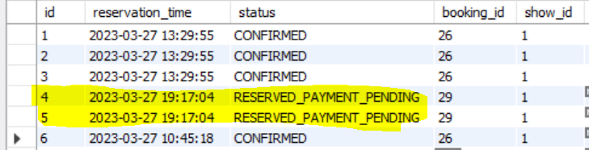

**Prompting for booking confirmation:**

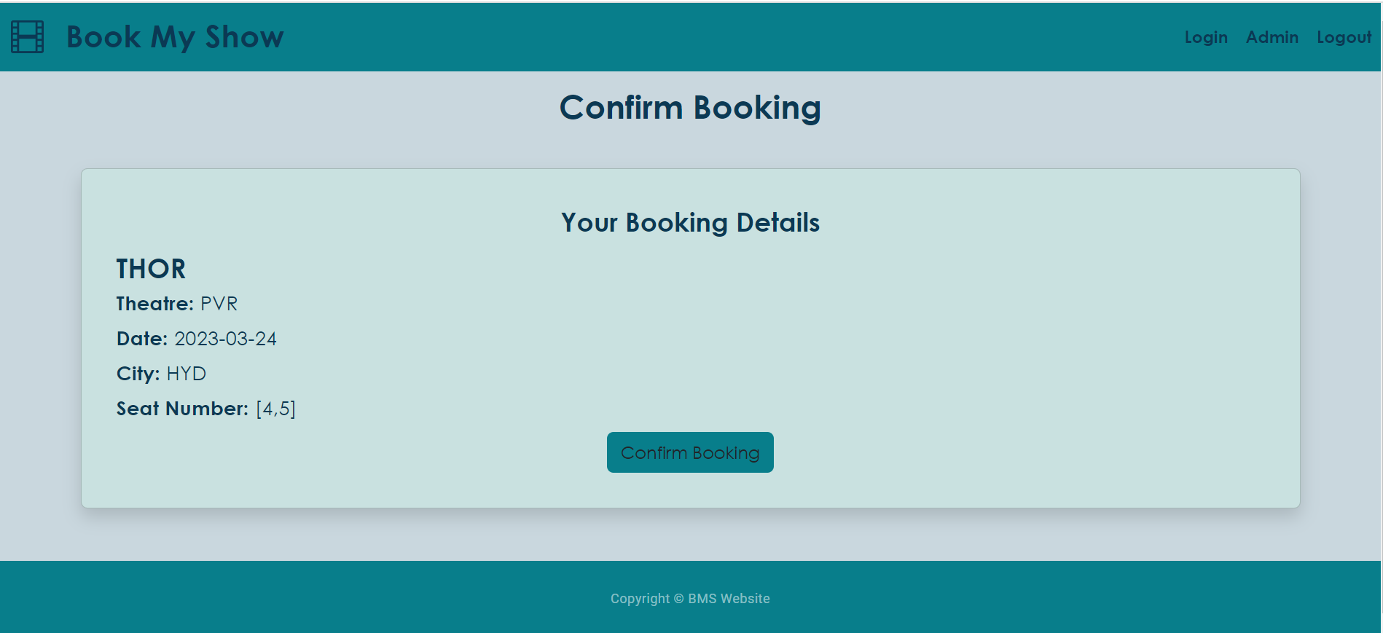

**After confirmation by user:** Entries of our DB

